Elytra Studios Website — Network Throttling Performance Report
Target site: elytrastudios.com | Tool used: Chrome DevTools Network Panel

1. Objective
This report compares the load performance of the Elytra Studios website under two network conditions — simulated 3G and No Throttling (full local network speed) — using Chrome DevTools with browser cache disabled in both tests. The goal is to quantify the impact of slow network conditions on load time and to outline a resource-loading strategy for future development.

2. Test 1 — 3G Throttling
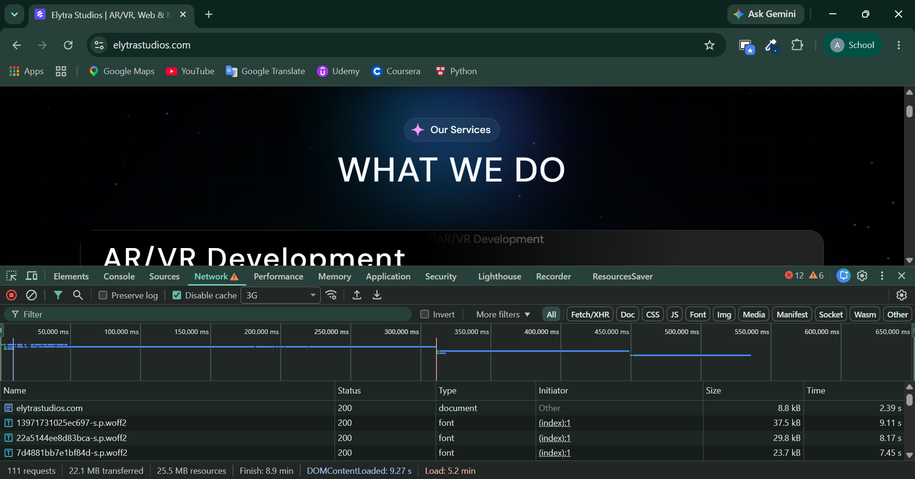
Figure 1: Chrome DevTools Network panel — 3G throttling, cache disabled.
Metric | Value | Notes
Requests | 111 | Total network requests fired
Data Transferred | 22.1 MB | Over-the-wire size (compressed)
Resource Size | 25.5 MB | Uncompressed resource size
DOMContentLoaded | 9.27 s | HTML parsed, DOM ready
Finish | 8.9 min | All requests fully completed
Load Event | 5.2 min | window.onload fired
Console Errors / Warnings | 12 / 6 | Failed or flagged requests

3. Test 2 — No Throttling
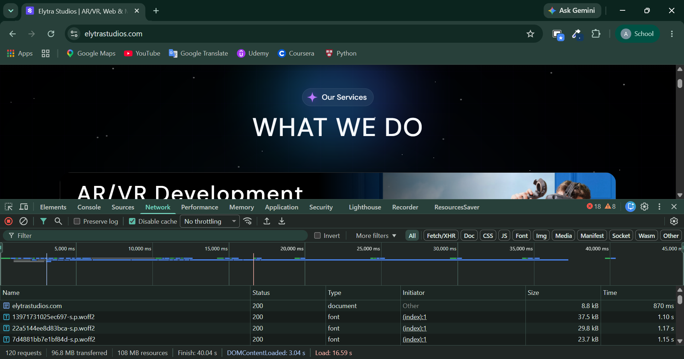
Figure 2: Chrome DevTools Network panel — No throttling, cache disabled.
Metric | Value | Notes
Requests | 120 | Total network requests fired
Data Transferred | 96.8 MB | Over-the-wire size (compressed)
Resource Size | 108 MB | Uncompressed resource size
DOMContentLoaded | 3.04 s | HTML parsed, DOM ready
Finish | 40.04 s | All requests fully completed
Load Event | 16.59 s | window.onload fired
Console Errors / Warnings | 18 / 8 | Failed or flagged requests

4. Comparison
Metric | 3G | No Throttling
DOMContentLoaded | 9.27 s | 3.04 s
Load Event | 5.2 min | 16.59 s
Finish (all requests) | 8.9 min | 40.04 s
Requests | 111 | 120
Data Transferred | 22.1 MB | 96.8 MB
As expected, throttling to 3G drastically increases every load milestone: DOMContentLoaded is roughly 3x slower, and the full load event is more than 18x slower compared to no throttling. The request count and transferred-data figures differ slightly between the two runs, which is normal — DevTools was recording a fresh, uncached page load in both cases, and browsers can adjust which resource variants (e.g. video quality, font subsets) get requested depending on effective connection speed.
The much larger data transfer under no throttling (96.8 MB vs 22.1 MB) suggests the browser is pulling in heavier resource variants — most likely full-resolution or uncompressed video/image assets — once bandwidth is not constrained, which was already flagged as a concern in the earlier media audit (oversized SVGs and uncompressed videos).

5. What Should Load First on a Slow Connection?
On a throttled connection, the browser still has to fetch everything eventually, but the perceived speed of a site depends on the order things appear, not just the total time. The general priority order is:
- HTML document itself — nothing can render until this arrives.
- Critical (above-the-fold) CSS — layout and text should appear immediately, even before images load.
- Web fonts — but only if they block text rendering; otherwise let text render in a fallback font first.
- Small structural JS needed for navigation/interactivity — deferred where possible.
- Hero/above-the-fold images — compressed and appropriately sized.
- Below-the-fold images, videos, embeds, analytics, and third-party scripts — these should load last, ideally lazily.
This ordering is often called the Critical Rendering Path: get the minimum needed for a usable, readable page on screen as fast as possible, and defer everything else.

5.1 Can this be controlled through code? Yes — several techniques:
a) Resource hints — tell the browser what matters most:
<link rel="preload" href="/fonts/main.woff2" as="font" crossorigin>
<link rel="preload" href="/images/hero.webp" as="image">
<link rel="preconnect" href="https://fonts.gstatic.com">
<link rel="dns-prefetch" href="https://cdn.example.com">
b) Control script execution order with async / defer:
<script src="/js/critical.js"></script> <!-- blocking, keep tiny -->
<script src="/js/analytics.js" async></script> <!-- loads in parallel, runs whenever ready -->
<script src="/js/app.js" defer></script> <!-- loads in parallel, runs after HTML parsed -->
c) Lazy-load offscreen images and videos natively:
<img src="/images/gallery-1.jpg" loading="lazy" alt="...">
<video src="/videos/demo.mp4" preload="none" poster="/images/demo-poster.jpg"></video>
d) Serve responsive/adaptive images so slow connections don't download desktop-sized assets:
<img
srcset="/img/hero-480.webp 480w, /img/hero-960.webp 960w, /img/hero-1920.webp 1920w"
sizes="(max-width: 600px) 480px, (max-width: 1200px) 960px, 1920px"
src="/img/hero-960.webp" alt="Hero">
e) Detect connection speed and adapt in JavaScript (Network Information API):
const conn = navigator.connection;
if (conn && (conn.saveData || conn.effectiveType.includes('2g'))) {
document.querySelectorAll('video').forEach(v => v.removeAttribute('autoplay'));
// load lower-resolution image set, skip non-essential widgets
}
f) Inline critical CSS in <head>, load the rest asynchronously:
<style>/* critical above-the-fold CSS inlined here */</style>
<link rel="preload" href="/css/main.css" as="style" onload="this.rel='stylesheet'">
g) Split JavaScript bundles (code-splitting) so the browser only downloads what the current view needs, instead of one large bundle, which is especially valuable on a framework like React or Vue using dynamic import().

